Organizational System Model
Sherri Hill Inc.

Sherri Hill
Sherri Hill’s exclusive collections epitomize the fashionable lifestyle of today’s contemporary women. Each look is designed to enhance and fit the female form with fashion-forward styling and wearability. Her design career began to gain recognition when various Miss USA, Miss Universe and Miss America contestants won titles in her gowns. Now, the Hill family business has a network of over 1,000 stores selling the brand in over 30 countries. Hill’s new corporate headquarters is in Austin, Texas. The company also maintains a design studio and showroom in Atlanta.

Mission
Hill's devotion to design is evident in her selection of beautiful fabrics and trimmings combined with innovative combinations of cuts to accentuate the best features of each and every woman.

Specialties  Designer Dresses, Women's Fashions  Website  http://www.sherrihill.com  Industry  Apparel & Fashion | Type  Privately Held  Company Size  11-50 employees  Founded  2008

Sherri Hill Inc. Staff

Founder & Owner  Sherri Hill  President & CEO  Dusty Hill  Vice President Of International Sales And Marketing  Cody Hill  Sales Representatives  Shepherd Duncan  Kaitlin Stoner  Sales Associate  Jessica Jordan  Sales Assistant  Ammar Moufti | Sales  Valeria Sotto  Marwa Bayazeed  Assistant Designer  Alisha Hill  Content Creator  Malory Prevatt  Shop Manager  Waleed Alakkad  Omar Alsaadi  Model  Summer Priester

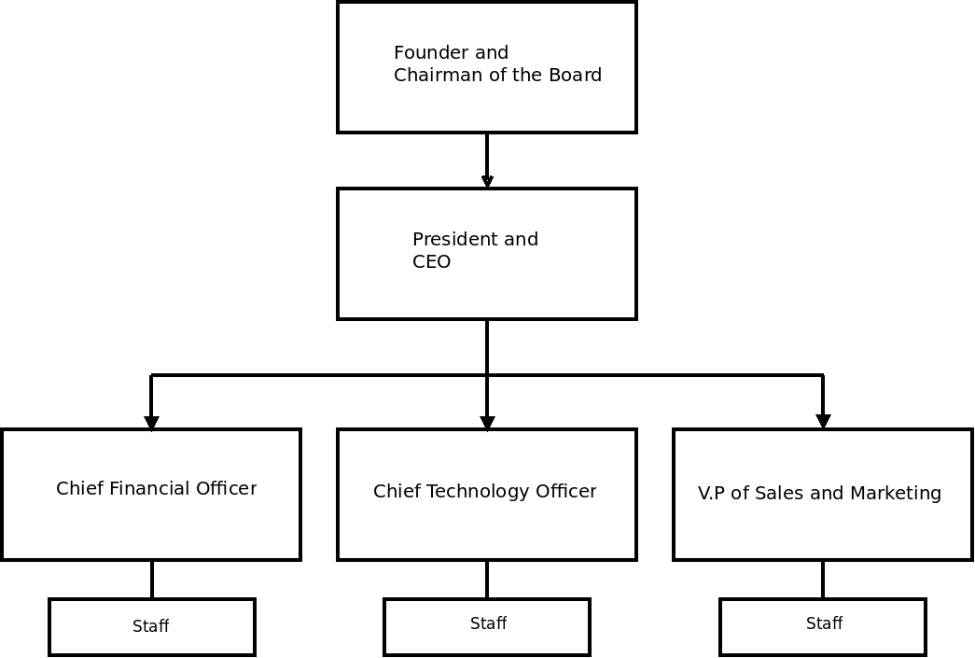

Organizational Structure Diagram

